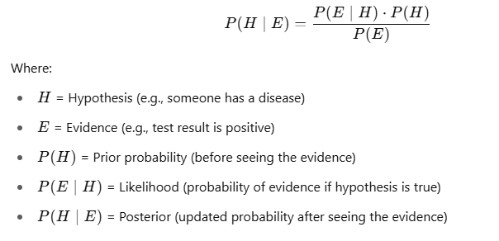



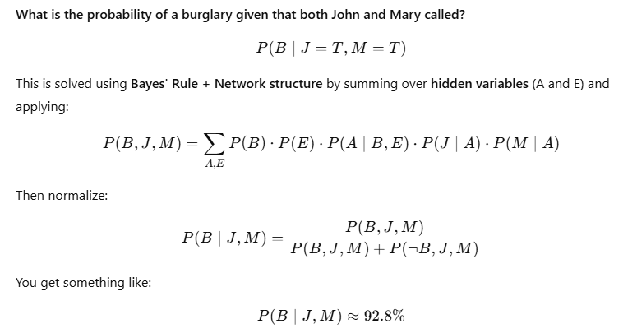

|  |  |  |
| --- | --- | --- |
| **Feature** | **Bayes’ Rule** | **Bayesian Network** |
| Purpose | Update probability with new evidence | Model and infer over multiple variables |
| Form | Single equation | Graphical model with multiple equations |
| Use Case | Binary reasoning (e.g., disease/test) | Complex systems (e.g., alarms, sensors) |
| Strength | Simplicity | Scalability and structure |



